**5. Bits y bytes**

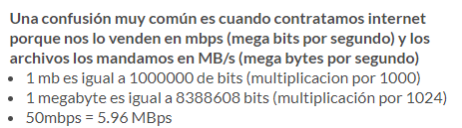

<https://platzi.com/clases/ingenieria/>

<https://www.youtube.com/watch?v=Pwo7HrOBw5Y&t=3s>

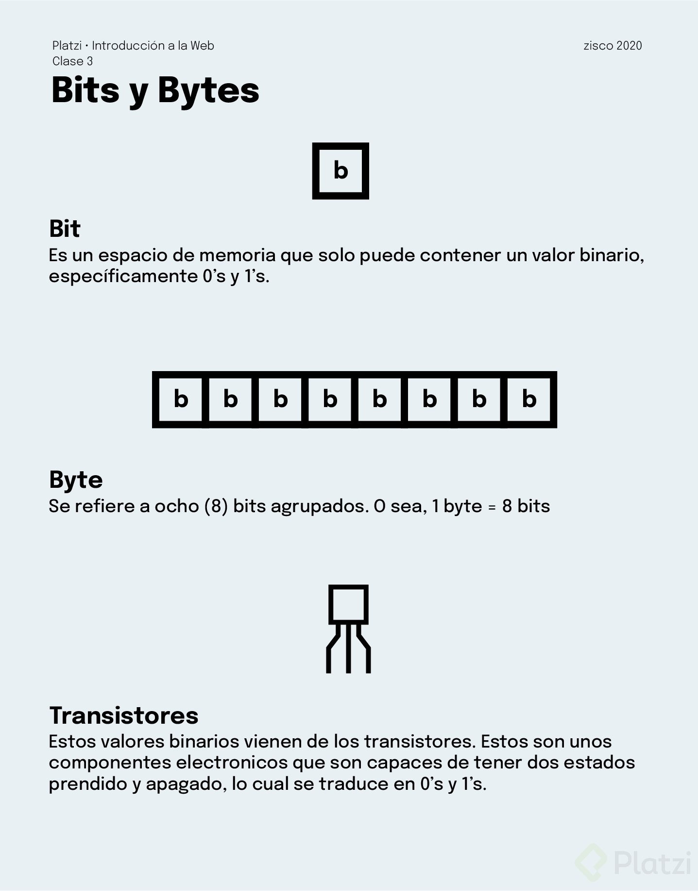

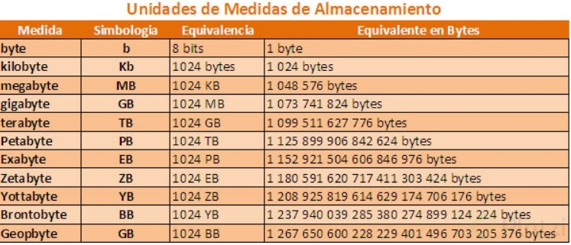

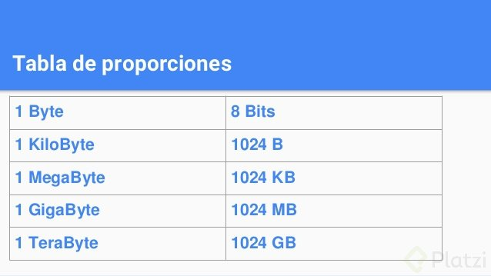

<https://www.youtube.com/watch?v=RVGIXfC4Xeg&feature=emb_logo>

<https://www.youtube.com/watch?v=K6aEiwbcl7c&t=1s&ab_channel=LareddeMario>